|  |  |  |  |  |  |
| --- | --- | --- | --- | --- | --- |
| **Safe Work Method Statement / Job Safety Environment Analysis / Job Safety Analysis** | | | | | |
| **Form Type:** (SWMS/JSEA/JSA) | |  | | **Project name/area** | | |  | |
| **Prepared By:** | |  | | **Date:** | | |  | |
| **Signature:** | |  | | | | | | |
| **Review completed by:** | |  | | **Date:** | | |  | |
| **Reviewer signature:** | |  | | | | | | |
| Work Activity | | | | | | | | |
| **Work Activity:** |  | | | | Name of High Risk Construction Work (where applicable): | | |  |
| http://www.seton.net.au/images/signs/signs/S0233.gifhttp://www.seton.net.au/images/signs/signs/S0122.gifMandatory PPE Required for the Activity | | |  | | | | | |
| **Mirvac Risk Matrix** | | | | | | | | |

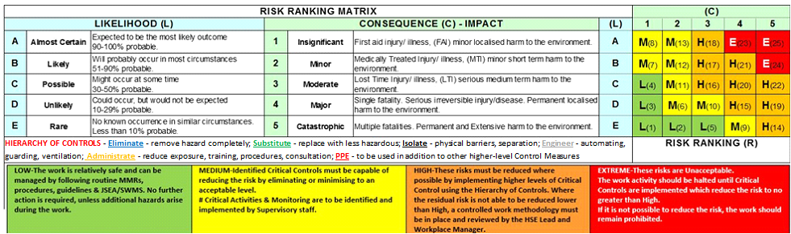

|  |  |  |  |  |  |  |  |  |  |  |
| --- | --- | --- | --- | --- | --- | --- | --- | --- | --- | --- |
| **Task Step**  Step by step sequence of activities | | | **Hazards**  Identify hazards associated with each step | **Risk**  **Before** | | **Controls** | | | **Risk**  **After** | **Responsible Person** |
|  | | |  |  | |  | | |  |  |
|  | | |  |  | |  | | |  |  |
|  | | |  |  | |  | | |  |  |
|  | | |  |  | |  | | |  |  |
|  | | |  |  | |  | | |  |  |
|  | | |  |  | |  | | |  |  |
|  | | |  |  | |  | | |  |  |
|  | | |  |  | |  | | |  |  |
|  | | |  |  | |  | | |  |  |
|  | | |  |  | |  | | |  |  |
|  | | |  |  | |  | | |  |  |
|  | | |  |  | |  | | |  |  |
|  | | |  |  | |  | | |  |  |
|  | | |  |  | |  | | |  |  |
|  | | |  |  | |  | | |  |  |
|  | | |  |  | |  | | |  |  |
|  | | |  |  | |  | | |  |  |
|  | | |  |  | |  | | |  |  |
|  | | |  |  | |  | | |  |  |
| **Qualification / Competencies / Licenses / Training Required** | | | **Date Received** | | | **Participant** | | | **Facilitation / Qualifications** | |
|  | | |  | | |  | | |  | |
|  | | |  | | |  | | |  | |
|  | | |  | | |  | | |  | |
|  | | |  | | |  | | |  | |
|  | | |  | | |  | | |  | |
|  | | |  | | |  | | |  | |
|  | | |  | | |  | | |  | |
| **Plant & Equipment Required:** | |  | | | | | **Tools Required:** |  | | |
| **Hazardous Substances to be used on site:** | |  | | | | |
| Sign Off | | | | | | | | | | |
| By signing this document, you acknowledge and accept your responsibility to co-operate with the controller of the premises to ensure a safe work environment and to take reasonable care of yourself and others while carrying out your work. You acknowledge that you have been consulted in the development of this document. | | | | | | | | | | |
| **THE FOLLOWING PEOPLE HAVE BEEN CONSULTED ON THE DEVELOPMENMT OF THIS DOCUMENT** | | | | | | | | | |
| **Name & Role** | | | | **Signature** | | | | | |
|  | | | |  | | | | | |
|  | | | |  | | | | | |
|  | | | |  | | | | | |
|  | | | |  | | | | | |
|  | | | |  | | | | | |
|  | | | |  | | | | | |
|  | | | |  | | | | | |

|  |  |
| --- | --- |
| Site Rules and Development Information |  |
| **Additional Information and Instructions**  List any additional site rules or procedures which apply | **Development Documentation**  List Relevant Legislation, Regulations, Standards or Codes or Practice |
| Mirvac strives to implement higher order controls for critical risk. Refer to the Hierarchy of Controls Triangle that provides examples of the use of controls that sit above PPE and Administrative Controls. Please refer to the Mirvac MRACs to assist in preparing your SWMS, JSEA, JSA. |  |